PROGRAM : MEDICAL RECORDS AND APPOINTMENT SCHEDULER

Input:

#include<conio.h>

#include<string>
#include<iomanip>

#include<iostream>

using namespace std;
static int abc = 1, i = 1, j = 1, k = 1, l = 1;

class vIRTUAL

{
public:virtual void get();

virtual void put();
string name, time;

int age;

};
void vIRTUAL::get()

{
system("cls");

cin.ignore();

cout << "\nENTER THE PATIENTS NAME : ";
getline(cin, name);

cout << "\nENTER APPOINTMENT TIME : ";
getline(cin, time);

cout << "\nENTER AGE : ";
cin >> age;

cout << "\nAPOINTMENT NUMBER:";

}

void vIRTUAL::put()
{

cout << "\nNAME : " << name;

cout << "\nAGE : " << age;
cout << "\nTIME : " << time << endl << endl;

}

class salary:public vIRTUAL
{

string name, wpos;

int wage, wsalary;
public:

void operator ++(); //operator overloading
void sget()

{

system("cls");
cin.ignore();

cout << "\nENTER NAME : ";
getline(cin, name);

cout << "\nENTER AGE :";
cin >> wage;

cout << "\nENTER SALARY : ";
cin >> wsalary;

cin.ignore();
cout << "\nWORKING POSITION : ";

getline(cin, wpos);
_getch();

}

void sput()
{

cout << "NAME"<<setw(15)<<": " << name << "\nAGE"<<setw(16)<<": " << wage <<
"\nWORKING POSITION : " << wpos << "\nSALARY"<<setw(13)<<": " << wsalary << endl << endl;

};

};

void salary::operator++()
{

int o;
cout << "ENTER INCREMENT AMOUNT :";

cin >> o;
wsalary=wsalary+o;

cout << "SALARY UPDATED SUCCESSFULLY";
_getch();

}

salary S[10];

class info :public vIRTUAL
{

public:

void geti()
{

get();
}

void puti()
{

put();
}

};

class RAJ :public info
{

public:
void getr()

{
get();

}
void putr()

{
put();

}
};

RAJ a[3];

class SHREYAS :public info
{

public:

void gets()
{

get();
}

void puts()
{

put();
}

};
SHREYAS b[3];

class SAISH :public info

{
public:void getsa()

{
get();

}

void putsa()
{

put();
}

};

SAISH c[3];

void menu()
{

system("cls");

cout << "\n";
cout << "\n";

cout << "\t\t |*****************************************|\n";
cout << "\t\t | MAIN MENU |\n";

cout << "\t\t | HOSPITAL MANAGEMENT SYSTEM |\n";
cout << "\t\t |*****************************************|\n";

cout << "\n--------------------------------------------------------------------------------------\n"; cout << "\t\t\tPLEASE SELECT ANY OPTION \n";

cout << "\n\t\tPRESS 1 FOR AVAILABLE DOCTOR INFORMATION \n\n"; cout << "\n\t\tPRESS 2 FOR DOCTOR APPOINTMENT \n\n";

cout << "\n\t\tPRESS 3 FOR SAVING STAFF INFORMATION \n\n"; cout << "\n\t\tPRESS 4 CHECK PATIENT APPOINTMENT MENU \n\n"; cout << "\n\t\tPRESS 5 CHECKING STAFF INFORMATION MENU \n\n"; cout << "\n\t\tPRESS 6 TO INCREASE SALARY OF STAFF\n\n";

cout << "\n\t\tPRESS 7 FOR LOGOUT \n\n";

cout <<

"\n==================================================================================

======\n";
cout << "\n\n\t\tPLEASE ENTER YOUR CHOICE:";

}

void drinfo()

{
system("cls");

cout <<

"\n==================================================================================

============\n";
cout << "\n\n\t\t(Three Doctor Available) \n\n \t\t[Information And Timing Are Given Below]\n";

cout << "\n----------------------------------------------------------------------------------------------\n"; cout << "\t\t Dr.Raj(skin specialist)\n\n";

cout << "\t\t\t [Timimg] \t\t\t\n";
cout << "\tMonday To Friday\t\t9AM to 5PM\n";

cout << "\tSaturday \t\t9AM to 1PM\n";
cout << "\tSunday \t\t OFF\n";

cout << "\n----------------------------------------------------------------------------------------------\n";
cout << "\t\t Dr.Shreyas(child specialist)\n\n";

cout << "\t\t\t [Timimg] \t\t\t\n";
cout << "\tMonday To Friday\t\t2PM to 10PM\n";

cout << "\tSaturday \t\t8AM to 1PM\n";
cout << "\tSunday \t\t12AM to 9PM\n";

cout << "\n----------------------------------------------------------------------------------------------\n";
cout << "\t\t Dr.Saish(eye specialist)\n\n";

cout << "\t\t\t [Timimg] \t\t\t\n";
cout << "\tMonday To Friday\t\t8AM to 5PM\n";

cout << "\tSaturday \t\t10AM to 1PM\n";
cout << "\tSunday \t\t OFF \n";

cout << "\n----------------------------------------------------------------------------------------------\n";
cout << "\nPress any key to Continue";

_getch();
system("cls");

}

void appt()
{

system("cls");

int choice;

cout << "\n\n\t\tPress 1 for Dr.Raj \n\n\t\tPress 2 for Dr.Shreyas \n\n\t\tPress 3 for Dr.Saish\n"; cin >> choice;

if (choice == 1)
{

if (i > 2)
{

cout << "APPOINTMENTS FULL FOR TODAY";
_getch();

}
else

{
a[i].getr();

cout << i;
_getch();

i++;

}
}

if (choice == 2)

{
if (j > 2)

{

cout << "APPOINTMENTS FULL FOR TODAY";
_getch();

}
else

{

b[j].gets();
cout << j;

_getch();
j++;

}
}

if (choice == 3)

{
if (k > 2)

{
cout << "APPOINTMENTS FULL FOR TODAY";

_getch();
}

else
{

c[k].getsa();
cout << k;

_getch();
k++;

}
}

}
void aptshow()

{
system("cls");

int choice;

cout << "\n\n\t\tPress 1 for Dr.Raj \n\n\t\tPress 2 for Dr.Shreyas \n\n\t\tPress 3 for Dr.Saish\n"; cin >> choice;

if (choice == 1)

{
if (i == 1)

{
cout << " NO APPOINTMENTS FOR TODAY";

_getch();
}

else
{

system("cls");
for (int x = 1; x < i; x++)

{
cout << "APPOINTMENT NO : " << x;

a[x].putr();
}

_getch();

}

}

if (choice == 2)
{

if (j == 1)
{

cout << " NO APPOINTMENTS FOR TODAY";
_getch();

}

else
{

system("cls");
for (int x = 1; x < j; x++)

{

cout << "APPOINTMENT NO : " << x;
b[x].puts();

}
_getch();

}
}

if (choice == 3)

{
if (k == 1)

{
cout << "NO APPOINTMENTS FOR TODAY";

_getch();
}

else
{

system("cls");
for (int x = 1; x < k; x++)

{
cout << "APPOINTMENT NO : " << x;

c[x].putsa();
}

_getch();
}

}

}

int password()

{
int pass = 12345, a;

cout << "\n\nENTER PASSWORD : ";
cin >> a;

if (pass == a)
return 1;

else
{

cout << "WRONG PASSWORD";
_getch();

return 0;
}

}

class admin:public RAJ,public SHREYAS , public SAISH
{

public:string adminname;
admin() //CONSTRUCTOR//

{
cin.ignore();

cout << "ENTER USER NAME : ";
getline(cin, adminname);

}
~admin() //DESTRUCTOR//

{
system("cls");

cout << "SESSION CLOSED FOR USER : " << adminname; _getch();
}

};

int main()

{
int p;

char ch;

if (password())
{

admin ABC;

do {
menu();

cin >> ch;
if (ch == '1')

drinfo();
else if (ch == '2')

appt();
else if (ch == '3')

{
S[l].sget(); l++;

}

else if (ch == '4')
aptshow();

else if (ch == '5')
{

system("cls");
if (l == 1)

{

cout << "NO STAFF RECORDS AVAILABLE";
_getch();

}
else

{
for (int x = 1; x < l; x++)

{
cout << "EMPLOYEE NUM " << x << endl;

S[x].sput();
}

_getch();
}

}
else if (ch == '6')

{

system("cls");

if (l == 1)
{

cout << "NO STAFF RECORDS AVAILABLE";
_getch();

}
else

{
for (int x = 1; x < l; x++)

{
cout << "EMPLOYEE NUM " << x << endl;

S[x].sput();

}

cout << "\n\nENTER EMPLOYEE NUM :";
cin >> p;

if (p > l - 1 || p <1)

{
cout << "INVALID EMPLOYEE NUM";

_getch();
}

else
++S[p];

}
}

else if (ch == '7')
{

abc = 0;
}

} while (abc == 1);
}

}

Output:

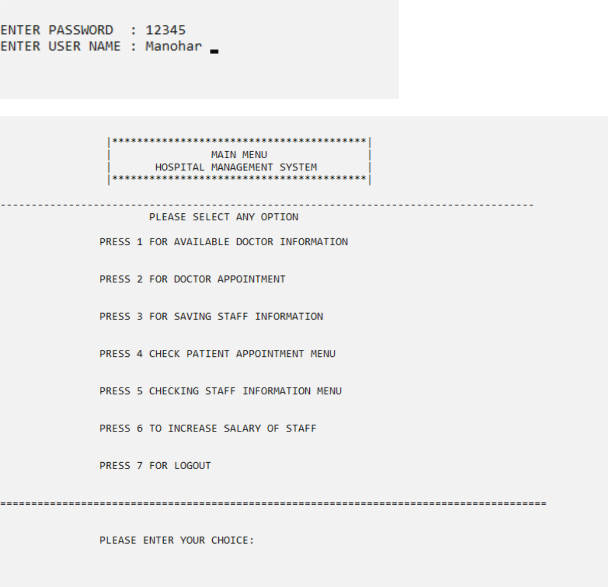

For choice 1

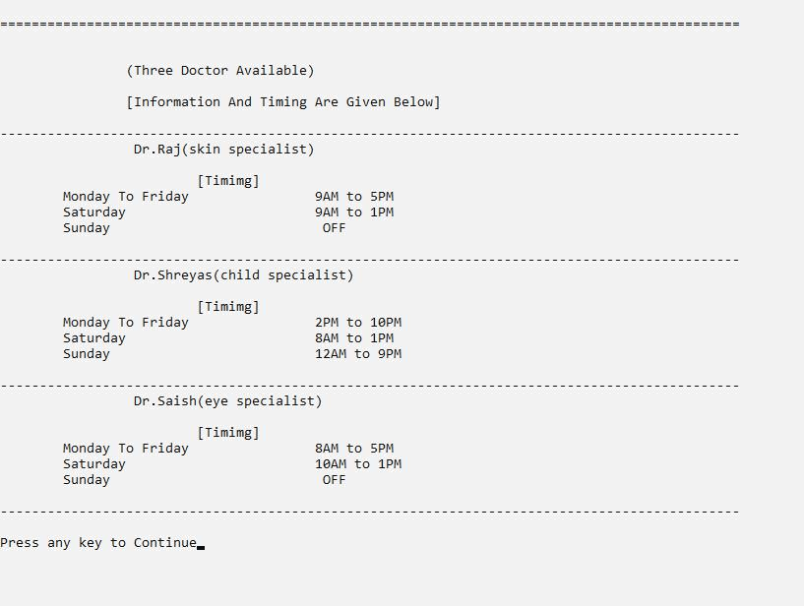

For choice 2

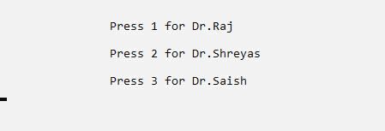

DR.RAJ appointments (input)

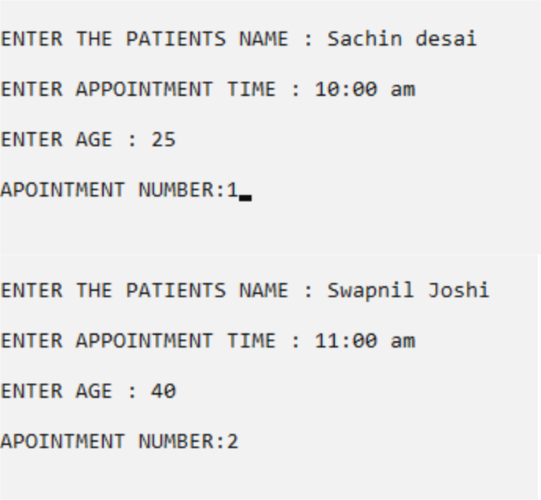

For 3rd appointment

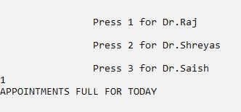

DR.SHREYAS appointments (input)

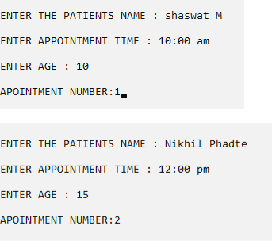

For 3rd appointment

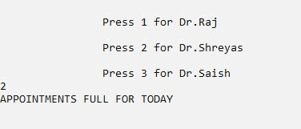

DR.SAISH appointments (input)

//NO ENTRIES MADE//

For choice 3

//first entry//

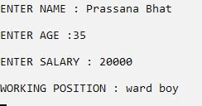

//second entry//

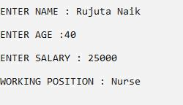

For choice 4

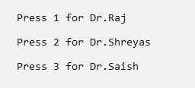

Dr.Raj appointments (output)

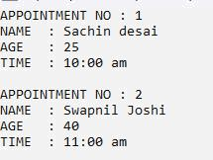

Dr.Shreyas appointments(output)

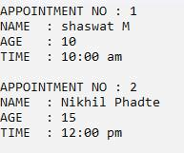

Dr.Saish appointments (output)

For choice 5

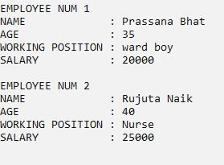

For choice 6

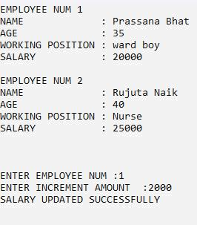

//UPDATE IN RECORDS SHOWN BELOW//

